(1) Rewrite the three java programs(i.e. employee details, average, grade) by using suitable access
modifiers?
(A)

(a) AVERAGE:

public class AvgAccMod
{
public static void main(String a[])
{
Marks k = new Marks();
k.averageOfMarks(100,90,70);
}
}

class Marks
{
private int m1,m2,m3;
public void averageOfMarks(int a,int b,int c)
{
double avg = (a+b+c)/3;
System.out.println("students marks average is = "+ avg);
}
}

OUTPUT:

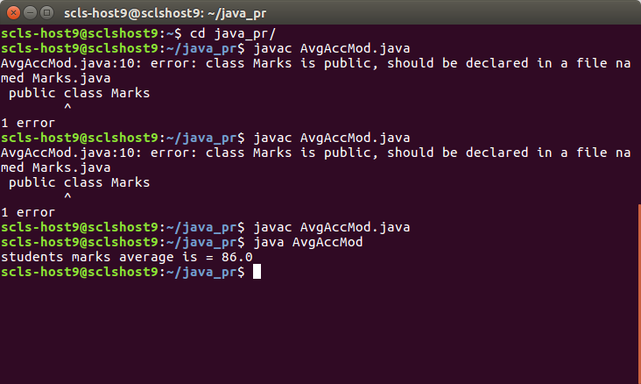

(b) LARGEST OF 3 NUMBERS:

public class LargestOf3Mod
{
public static void main(String args[])
{
Numbers k = new Numbers();
k.calcLargest(10,30,20);
}
}

class Numbers
{
private int a,b,c;
public void calcLargest(int a,int b, int c)
{
if(a==b && b==c)
System.out.println(" All the three numbers are same");
else if(a==b && b>c)
System.out.println("Both a and b are largest numbers");
else if(a==c && c>b)
System.out.println("Both a and c are largest numbers");
else if(b==c && c>a)
System.out.println("Both b and c are largest number");
else if(a>b && a>c)
System.out.println("the a is largest number");
else if(b>a && b>c)
System.out.println("the b is largest number");
else if(c>a && c>b)
System.out.println("the c is largest number");

}
}
OUTPUT:
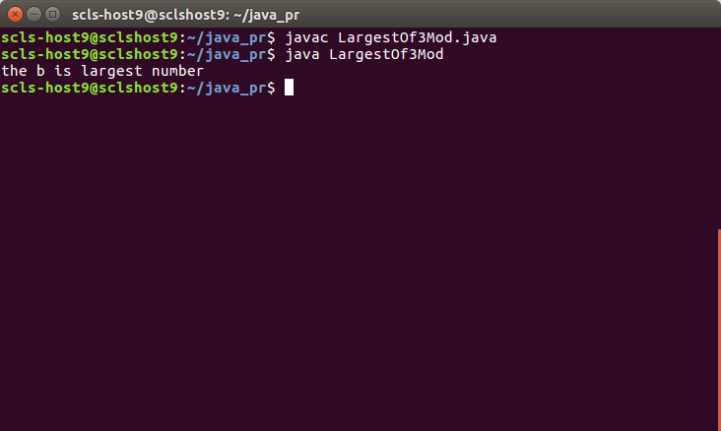

(c) EMPLOYEE DETAILS:

public class EmployeeMod
{
public static void main(String args[])
{
EmployeeDetails k = new EmployeeDetails();
k.details("SRIRAM","40","66666666660000000");
k.details("sudheer","40","84776836826327");
}

}

class EmployeeDetails
{
private String name;
private String age;
private String salary;
public void details(String name,String age,String salary)
{
System.out.println();
System.out.println("Employee Details");
System.out.println("Name is "+name);
System.out.println("age is"+age);
System.out.println("Salary is"+salary);
}
}

OUTPUT :
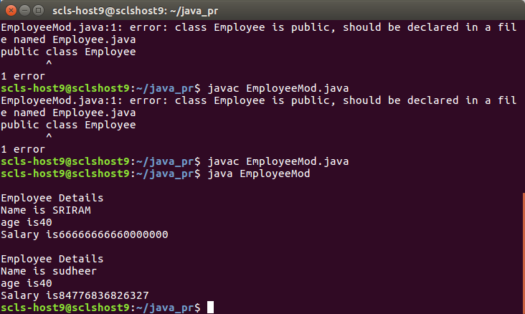

(2) Prepare a document about java access modifiers.
(A)
There are 4 types of access modifiers in java.
They are :
(a) Public Access Modifiers:
It is accessible everywhere. That means it is visible to entire java environment.
(b) default Access Modifiers:
It allows package level visibility. Even if we don’t use any modifier, the class or methods
or variables are treated as default access modifier.
(c) Private Access Modifiers:
The private access modifier is accessible only within class. If we apply private access
modifier to data, methods and constructor, then they are accessable within the class only.
(d) Protected Access Modifiers:
It will allow package level visibility and sub-class in other packages.

(3) Write a java program by using static variable and static methods
(A)

public class StaticVariables
{
public static void main(String a[])
{
Marks.a=1;
Marks.b=2;
Marks.c = 3;
public class Assignment3
{
public static void main(String args[])
{
Marks.averageOfMarks();
Marks k = new Marks();
k.x = 100;
k.y = 200;
k.z = 300;
Marks k2 = new Marks();
System.out.println("sum of students"+k.sum());
System.out.println("sum of students"+k2.sum());
k.a = 20;
k2.a = 2;
System.out.println("sum of students"+k.a);

}
}

class Marks
{
static int a,b,c;
int x,y,z;

static void averageOfMarks()
{
// x, y , z directly can't used here to create an object of marks
double avg = (a+b+c)/3;
System.out.println("students marks average is = "+ avg);
}

int sum()
{
return x+y+z;
}
}

OUTPUT :

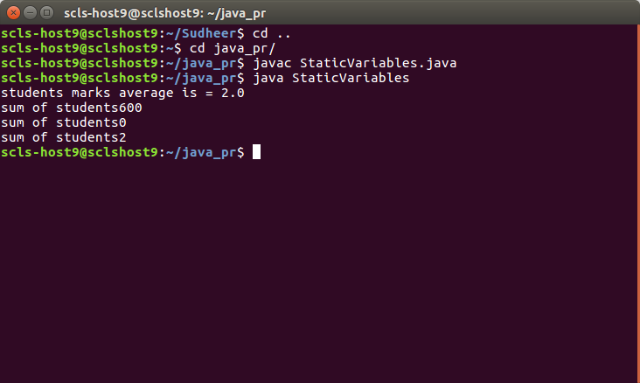

(4) Test the behaviour of private access modifiers
(A)

public class PrivateVariables
{
public static void main(String a[])
{
Marks k = new Marks();
k.averageOfMarks();
//k.a = 20;
//k.display();

}
}

class Marks
{
private int a=1,b=2,c=3;

void averageOfMarks()
{

double avg = (a+b+c)/3;
System.out.println("students marks average is = "+ avg);
display();
}
private void display()
{
System.out.println("display");
}
}

OUTPUT :

